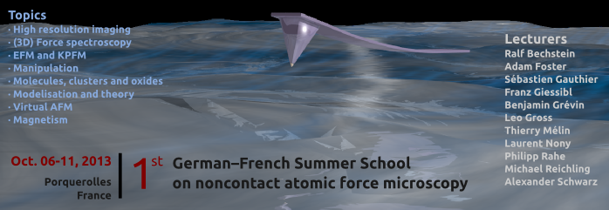
German-French Summer School
on noncontact atomic force microscopy

– Frequently-Asked-Question Session --

Dear colleague.

During the Summer School you will have the opportunity in a Frequently-Asked-Question session of 90 minutes to ask the lecturers your most urgent questions related to nc-AFM and related experimental techniques. In order to gather and sort the questions we kindly ask you to fill out this template.

You can ask up to 3 questions and use one or several categories from the list below. Send this form by Email to barth@cinam.univ-mrs.fr and reichling@uos.de until September 8th
(Email subject: ncAFM-school | FAQ: <your name> - <your institution> - <your country>).

Surname  (optional) | Name  (optional) | Institution  (optional) | Country | Category  (see list below) | Question

Category
nc-AFM, EFM, KPFM, MFM, Spectroscopy, Manipulation, Surfaces, Oxides, Molecules, Clusters, QPlus, UHV exp., Air exp., Virtual AFM, Modelling, Data visualization and analysis, ...

Example

Surname | Name | Institution | Country | Topic  (see list below) | Question
Clemens | Barth | CINaM | France | nc-AFM | Which AFM tips must I use to obtain the true atomic resolution?
Michael | Reichling | Uni Osnabrueck | Germany | KPFM | Must I metallize the AFM tips before conducting KPFM measurements?

